EE 5356- DIGITAL IMAGE PROCESSING

ASSIGNMENT #3

COLOR TRANSFORMATION

NAME: PAVAI ARCHIMEDES

ST ID: 1001233996

**The test image, Girl256color.raw (the size is 256*256 pixels), for this assignment is available at the class website.**

**Problem 1: RGB component decomposition**

**1) Decompose a given 24bit color image (raw format) into 3 Red, Green, and Blue components and show those images in your report and explain the procedure (how to get these.)**

**2) Reconstruct the color image from these three RGB components, and show the reconstructed color image with your explanation.**

**PROGRAM:**

clc;

clear all;

color_image=fopen('C:\Users\PAVAI ARCHIMEDES\Desktop\girl256color.raw');

img = fread(color_image);

for count=1:3:256*256*3

R(ceil((count)/3))=img(count);

end

for count=2:3:256*256*3

G(ceil((count-1)/3))=img(count);

end

for count=3:3:256*256*3

B(ceil((count-2)/3))=img(count);

end

[row col]=size(R)

c=sqrt(col);

for m=1:c

for n=1:c

R1(m,n)=R(n+(256*(m-1)));

end

end

for m=1:c

for n=1:c

G1(m,n)=G(n+(256*(m-1)));

end

end

for m=1:c

for n=1:c

B1(m,n)=B(n+(256*(m-1)));

end

end

img_1=zeros(256,256,3);

img_2=zeros(256,256,3);

img_3=zeros(256,256,3);

img=zeros(256,256,3);

img_1(:,:,1)=R1(:,:);

image(uint8(img_1));

image

title('Red Components of RGB image');

figure;

img_2(:,:,2)=G1(:,:);

image(uint8(img_2));

image

title('Green Components of RGB image');

figure;

img_3(:,:,3)=B1(:,:);

image(uint8(img_3));

image

title('Blue Components of RGB image');

figure;

img(:,:,1)=img_1(:,:,1);

img(:,:,2)=img_2(:,:,2);

img(:,:,3)=img_3(:,:,3);

image(uint8(img));

title('Reconstructed Image-girl256color.raw(256*256)');

figure;

COLOR TRANSFORMATION:

Y=(0.299*R1)+(0.587*G1)+(0.114*B1);

Ut=(-0.147*R1)+(-0.289*G1)+(0.436*G1);

Vt=(0.615*R1)+(-0.515*G1)+(-0.100*B1);

Yd=((0.257*R1)+(0.504*G1)+(0.098*B1))+16;

Cb=((-0.148*R1)+(-0.291*G1)+(0.439*B1))+128;

Cr=((0.439*R1)+(-0.368*G1)+(-0.071*B1))+128;

subplot (3,2,1);

imshow (Y,[]);

title ('Y Component');

subplot (3,2,3);

imshow (Ut,[]);

title ('Ut Component');subplot (3,2,5);

imshow (Vt,[]);

title ('Vt Component');

subplot (3,2,2);

imshow (Yd,[]);

title ('Yd Component');

subplot (3,2,4);

imshow (Cb,[]);

title ('Cb Component');

subplot (3,2,6);

imshow (Cr,[]);

title ('Cr Component');

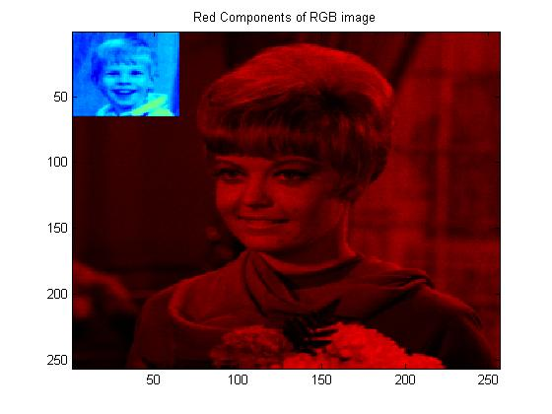

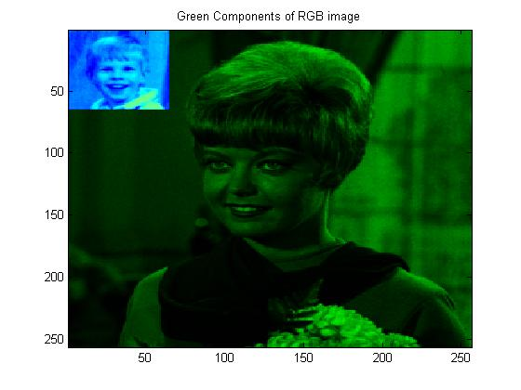

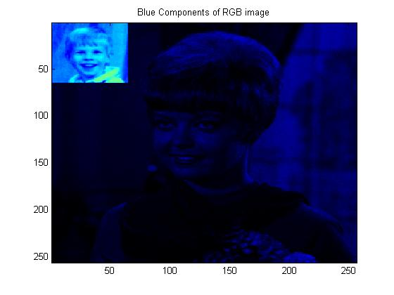

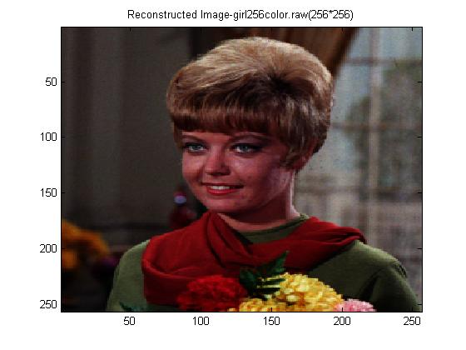

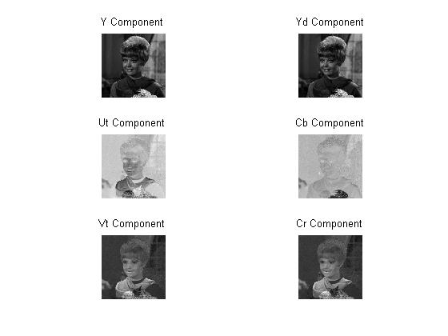

**CONCLUSION:**

The image is a 256*256 RGB image. The image is stored in a column vector matrix with 196608(256*256*3) rows and 1 column.

* The red components on the image constitute the 1st, 4th, 7th etc. components on the image.
* The blue components constitute the 2nd, 5th, 8th etc. components on the image.
* The green components constitute the 3rd, 6th and 9th etc. components on the image.

The individual components are separated using a ceil function. The Size of each individual component is stored in a row vector which constitutes of 65536(256*26) columns and one row.

* The individual red, green and blue components are separated and displayed in the figures 1, 2 &3.
* The reconstruction of image is carried out by combining these RGB components which is explained in the matlab code and displayed in figure 4.
* The results of Y, Vt, Ut, Yd, Cb and Cr are calculated using the formulas in the matlab code and are displayed in the figure above.